DOZOR body camera short manual

Table of contents
1 DOZOR body camera 2
1.1 DOZOR body camera short description 2
1.2 DOZOR body camera structure 2
1.3 Operation of DOZOR body camera 2
1.3.1 Battery charging 2
1.3.2 Turning on and off DOZOR body camera 2
1.3.3 Usage of DOZOR body camera 3
1.3.4 G-Sensor in DOZOR body camera 3
1.4 DOZOR body camera specification 3
1.5 DOZOR body camera accessories list 4
2 DOZOR Light – software for setup and playback. 5
2.1.1 Installing and using of DOZOR Light 5
3 Data backup and charging DOZOR TERMINAL-28 6
3.1 Specification of TERMINAL-28 6
3.2 Structure of TERMINAL-28 7
4 Data backup and charging DOZOR TERMINAL-6 8
4.1 Specification of TERMINAL-6 8
4.1 Structure of TERMINAL-6 8
5 Professional software for DOZOR body cameras – “DOZOR Pro” 10
5.1 Functions of “DOZOR Pro” software 10
5.2 Interface of “DOZOR Pro” software 11
5.3 SW requirements 11

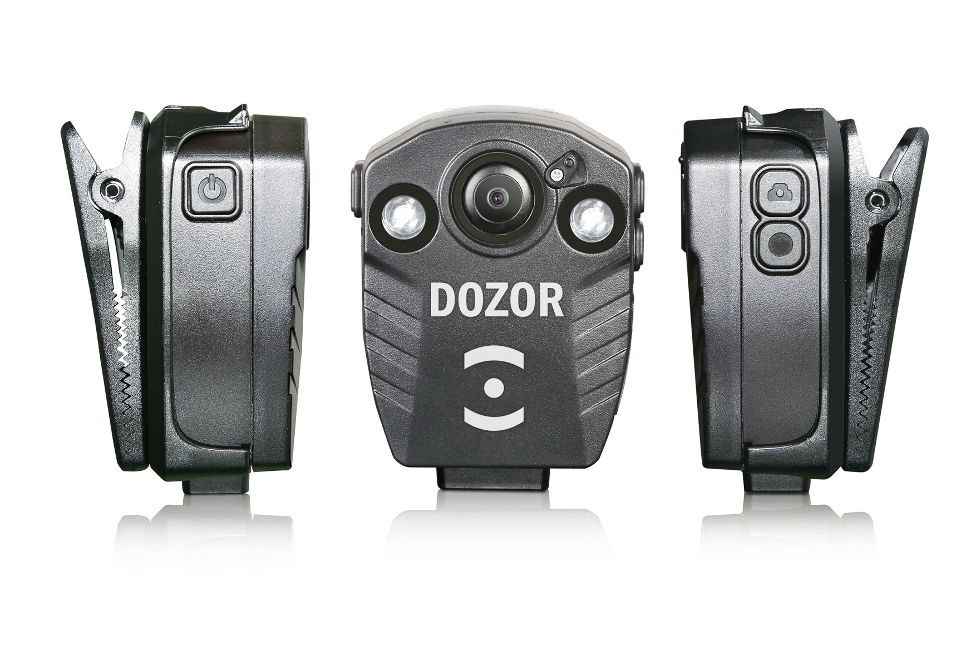

DOZOR body camera

DOZOR body camera short description

DOZOR body camera is portable camera designed for long-time (up to 8hous) HD-video Recording in mode 24*7*365. It is designed for indoor and outdoor use. It is easy-to use, it has vandalproof, rainproof housing and Night mode with White led and IR led. DOZOR body camera is light weight (100gr only) and designed for police, security and other users who need high-quality video+ audio recording and photo. It is easy to set up DOZOR body camera to any kind of dress.

DOZOR body camera structure

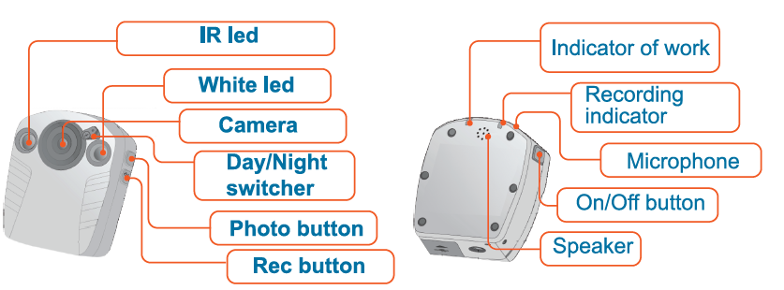

Operation of DOZOR body camera

Battery charging
Use AC or Car power adaptor or USB port of PC and USB- cable for charging. Also DOZOR body cameras can be charged in DOZOR Terminals. Charging can take about 4hours or more. During the charging red indicator on the back of the camera will be blinking. When the battery is fully charged – red indicator will be on constantly.

Turning on and off DOZOR body camera
Press POWER ON button for 5 seconds for turning on DOZOR body camera. After DOZOR body camera is on – it will make “beep” and red indicator will be on constantly – it means that the camera is in standby mode now. Press POWER ON button for 3 seconds for turning off DOZOR body camera, it will make “beep” and turn off red indicator will fade.

Please do not press on buttons too hard!

Usage of DOZOR body camera

Before start please charge the battery. Then set up DOZOR body camera to your dress. We also recommend you to use safety cord, to protect DOZOR body camera from falling down. Then turn it on. For photo – shortly press photo button, the camera will make “beep” blink green once and make a photo. For video recording – “rec” button - the camera will make “beep” and green will start blinking. To stop recording – shortly press “rec” button again, green will stop blinking and red will shine constantly. All records and photos will be stored on built in memory. Photos – in .JPEG files, records – in .MOV files. Length of records can be set 10, 20 or 30 minutes (all settings can be done from PC with DOZOR SW, or DOZOR TERMINALs). When it is dark – use night mode (day/night switcher is on the front of the camera).

G-Sensor in DOZOR body camera
Each DOZOR body camera has built in G-sensor, which can activate video recording if the camera is hit or shaken in standby mode. Recording will continue 5 min, after that camera will return in standby mode. G-sensor can be disabled or enabled in settings.

DOZOR body camera specification

CAMERA
Field of View: | 160 Degrees (diagonal angle), 135 Degrees (horizontal angle)
Night Vision: | Yes – Two built-in Leds, 1st – white led, 2nd – IR led % & Ir cut filter for BW mode
Waterproof, Working temp: | Yes – IP65, -35℃— +55℃
LEDs on case: | Red – power, charging, Green - recording
Dimensions, weight: | ~2.5" x 2.0" x 1.0" ~ (75x55x25mm), ~ 100g
BATTERY
Type: | Built-in, Rechargeable, High-Capacity Lithium ion
Charging Time/Format: | 3-5 hrs. / USB via computer, AC-adaptor, or a vehicle-adaptor
Battery Life: | 7 hrs Continuous (2200mAh) / 8hrs Continuous (2600mAh) (2 types of batteries)  (24 hrs. Continuous - w/ optional Portable Power-Pack/Charger)
Battery Level: | Visual Indicator and Audible Alarm
VIDEO/IMAGE REVIEW
Video Output: | MicroUSB
Video Transfer: | USB 2.0
Compatibility: | Windows Operating Systems
Viewing Options: | Computer and Backup Terminal with VMS (up to 28 recorders same time)
Functions of VMS | Download, playback, copy, store, screenshot, name cameras, setup cameras, smart search
RECORDING
Video Quality: | Multiple Recording Resolutions  (1080p/30fps, 720p/30fps, 480p/30fps)
Video Standards: | NTSC and PAL
Audio: | Yes - Built-in, High-Fidelity Microphone, Selectable On/Off
Date & Time Stamp: | Yes - Selectable On/Off
Image “Snapshots”: | Yes - Capture still images up to 5 Megapixels
Stored Video, Length: | ~ 18 hrs. - w/ 32GB Storage (720p/30fps), ~ 12 hrs. - w/ 32GB Storage (1080p/30fps)
Storage Capacity: | Up to 32GB MicroSD (built in)
Storage Level: | Visual Indicator and Audible Alarm
G-Sensor: | Yes. Movement activated recording

DOZOR body camera accessories list
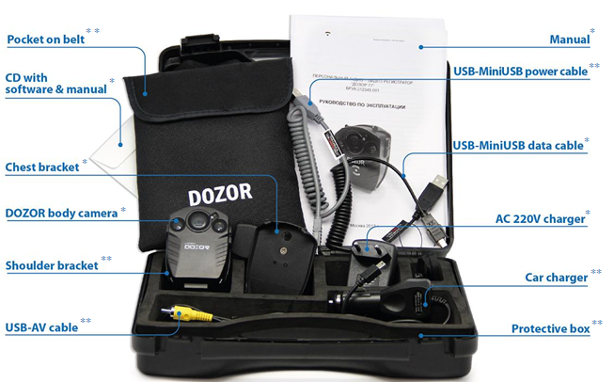
*default accessories
**extended accessories

DOZOR Light – software for setup and playback.

Software DOZOR Light is for fast setup of the camera and access to the memory of the camera

Installing and using of DOZOR Light

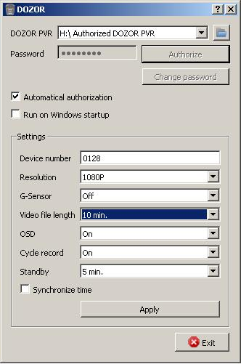
1. Run the file “DOZOR Light” file to install

2. Choose language (English or Russian) during installation

3. Run the SW (you must have Admin rights on this PC)

4. Connect DOZOR to PC by USB – it will appear in upper window of DOZOR tools interface

5. Choose DOZOR in upper window and press “Authorize” (or add mark in Automatic authorization)

6. Then you can open folder (upper right corner) – you will see DOZOR memory card and can copy and play all records (.MOV files).

(If in you will need to cut records – you can use this SW - http://www.solveigmm.com/en/products/video-splitter/ )

You can also change all settings

- Device Number

- Resolution – Set recording resolution 1080p/720p/480p

- G-sensor – if its ON – DOZOR will start 5 min recording automatically if you shake or hit it

- Video file length – length in minutes for each file 10/20/30min.

- OSD – show or not DATE & TIME on the record (ON is recommended).

- Cycle record – if its ON, DOZOR will delete oldest files for Newest when memory card is full. If its OFF – device will stop recording after memory is full (ON is recommended).

- Standby – in what time will DOZOR turn off if its not recording 2/5/10min or OFF – never turn off.

- Synchronize time – set in DOZOR same time as on your PC.

Attention!
As records are protected – you will see only empty folder if connect DOZOR to PC without DOZOR Light SW and without authorization.

Data backup and charging DOZOR TERMINAL-28
The Terminal-28 designed for professional use in big systems.

Specification of TERMINAL-28
- Ready for use, plug&play professional solution;
- Same-time connection up to 28 cameras for charging and data backup;
- Access is protected by locks, RFID-keys and passwords;
- 24Tb memory for long-time data saving;
- Sensor monitor;
- Network functions with remote access;
- Built in professional software DOZOR Pro;
- USB 2.0- port for data backup to flash drive;
- Power recovery system;
Spec | Data
Housing | Metal-vandalproof
Size of the terminal | 1370х500х400 (± 10) mm
Base size | 590х480 (± 10) mm
Weight of the terminal | 95 (± 10) kg
Number of supported Cameras | 28
PC | Intel Pentium 2Ghz, RAM 4Gb
HDD space | 24Tb (6 HDD by 4Tb)
Operation system | Windows 8
Sensor screen | 17’’ (TFT LCD)  resolution (1280х1024)
Electromechanical door lock | +
HID & EM Marine card controller | +
Backup interface | 1 USB 2.0 port
Built in camera | 640x480pxl
Speaker | +
Backup power system | +
Power of the terminal | AC198-242V / 50Hz, 350wt
Working temperature | +12… 35 ^{о}С

Structure of TERMINAL-28
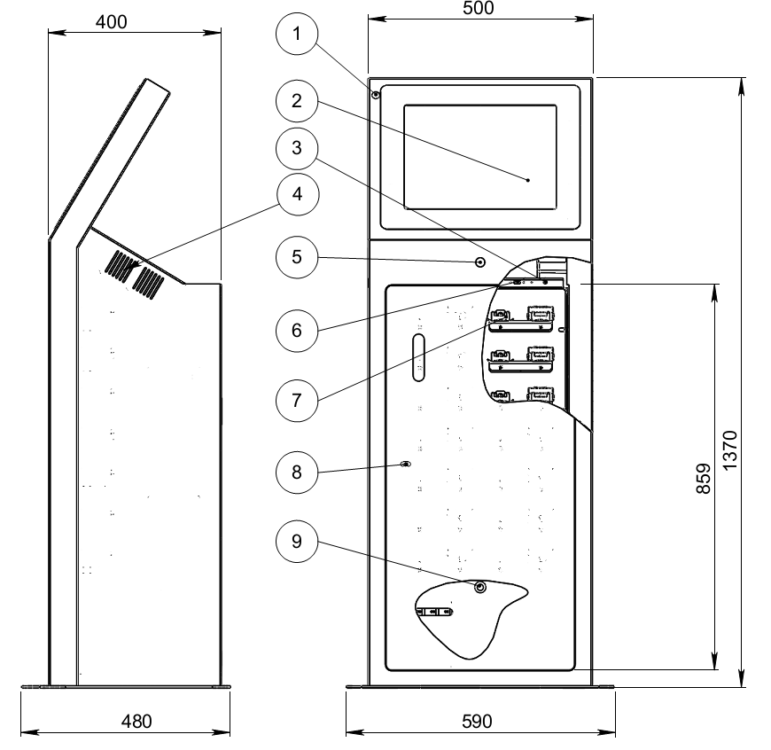

- - Camera,
- – Sensor screen,
- – Power on button,
- – Speaker,
- – EM Marine card controller,
- - USB 2.0 port,
- – Brackets for cameras
- – Mechanical door lock,
- – Backup power system power on button.

Data backup and charging DOZOR TERMINAL-6
The Terminal-6 designed for professional use in middle-size systems.

Specification of TERMINAL-6

- Ready for use, plug&play professional solution;
- Same-time connection up to 6 cameras for charging and data backup;
- Access is protected by passwords;
- 4Tb memory for long-time data saving;
- Network functions with remote access;
- Built in professional software DOZOR Pro;
- USB 2.0- port for data backup to flash drive;

Structure of TERMINAL-6

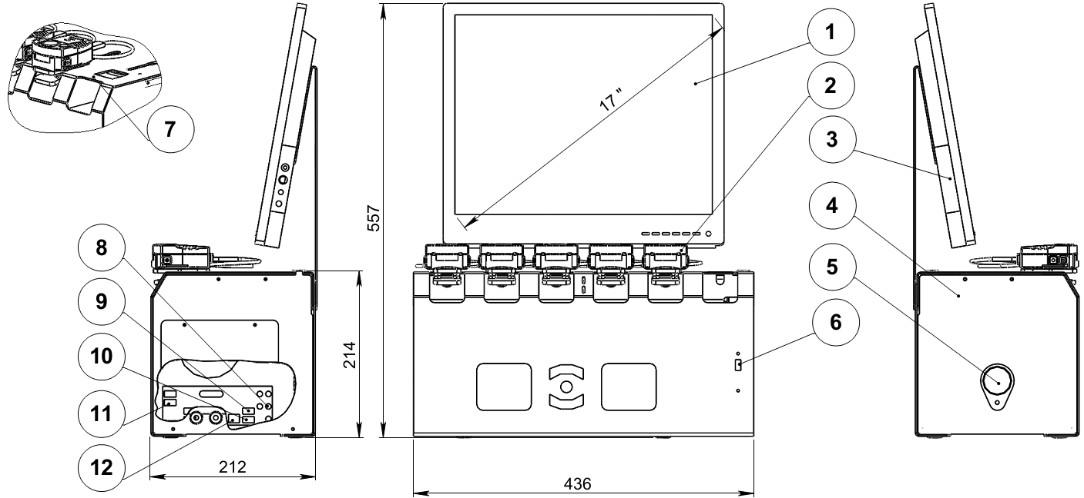

1-Monitor,
2-DOZOR body camera,
3-Speaker,
4-Case of the terminal-6
5-Power on/off button,
6- USB 2.0 port,
7-The socket for camera,
8-Audio jack,
9, 10- USB-ports for wireless mouse and keyboard,
11- USB-port,
12- Ethernet-port.

Professional software for DOZOR body cameras – “DOZOR Pro”

Functions of “DOZOR Pro” software

Main purpose of “DOZOR Pro” software is backup records from DOZOR body cameras and setting of cameras.
“DOZOR Pro” software can be set up on Windows-based or Libux-based PC.

Specification of “DOZOR Pro” software:

- graphical interface;
- backup of all or selected files;
- searching records by different criteria;
- playback of photos and video records;
- automatic delete of the records after selected period of time;
- comments to archived records;
- creating report of using cameras per period;
- recording of all actions of the operator;
- password protection of all actions with camera settings and records;
- user management;
- personal protection, delete or backup selected records;
- screenshots;
- changing of all settings of cameras;
- log file creation and management
- remote access:
- searching records by different criteria;
- playback of photos and video records;
- backup of selected files;
- log file view;

Interface of “DOZOR Pro” software
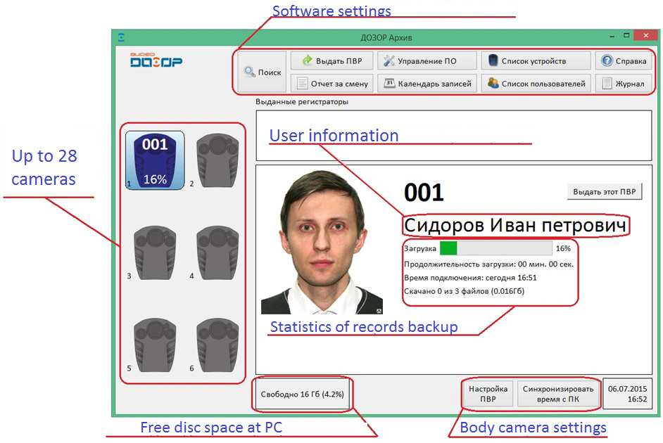

SW requirements

- IBM PC compatible with Intel Atom 1,6GHz or better
- Memory – 1Gb or more
- Video memory 256Mb or more
- HDD free space 50Gb or more
- Windows XP / Windows 7 / Windows 8 / Linux

